

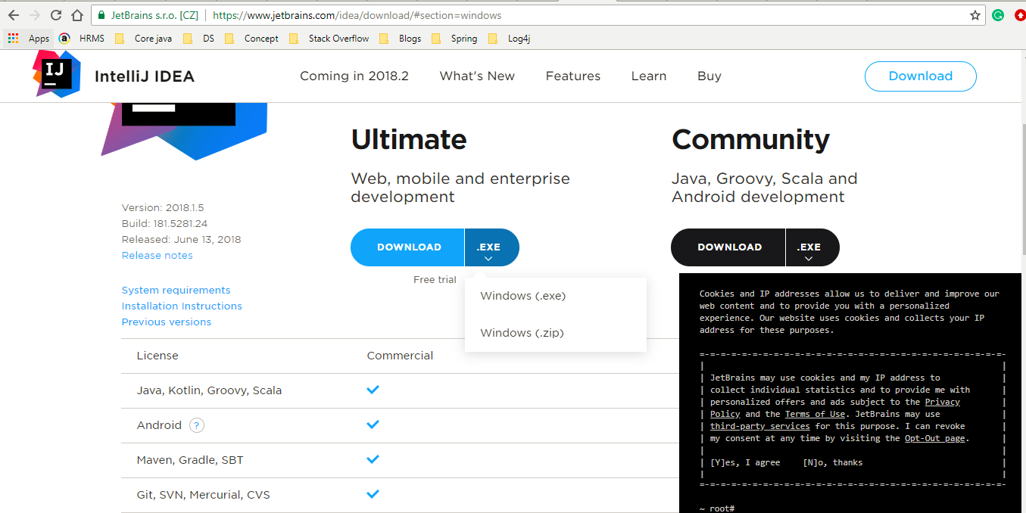

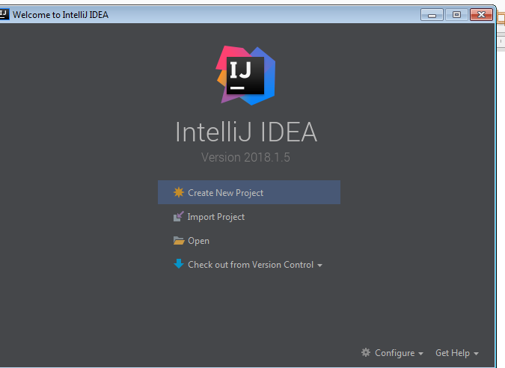
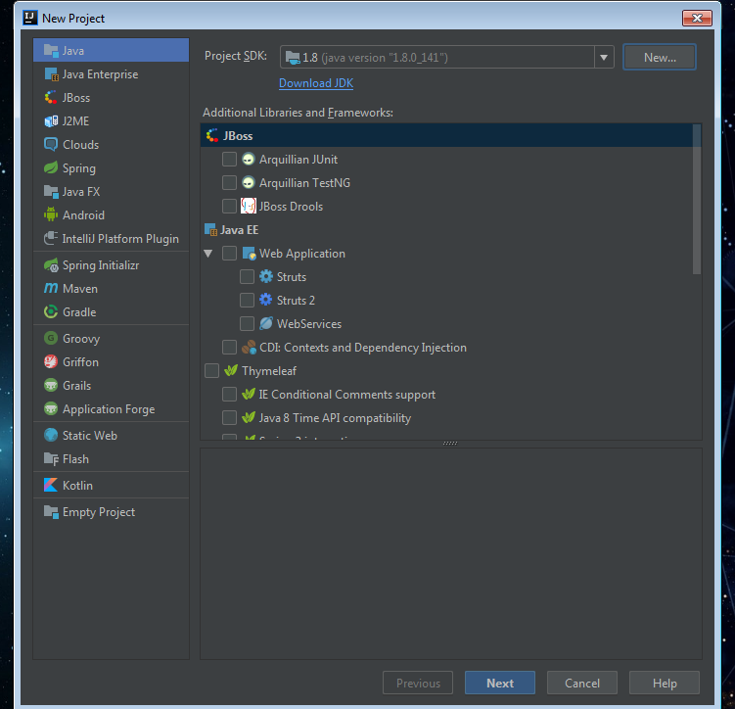

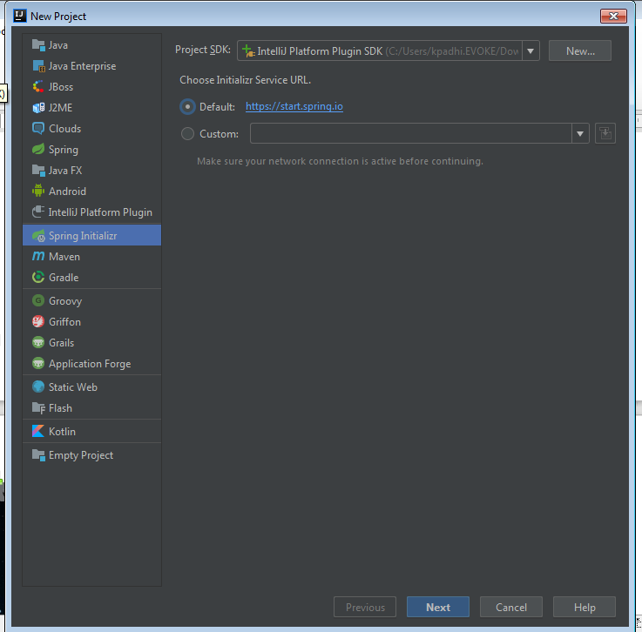
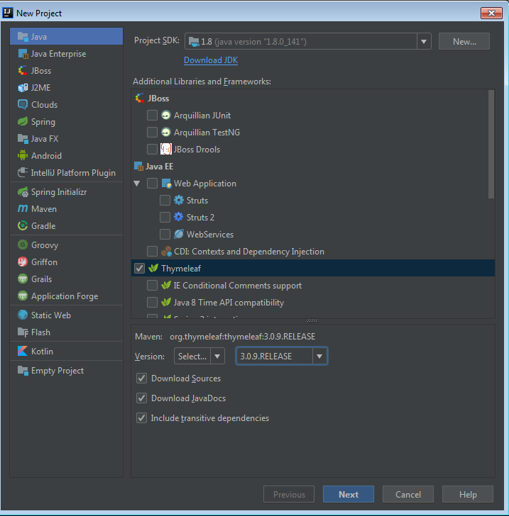

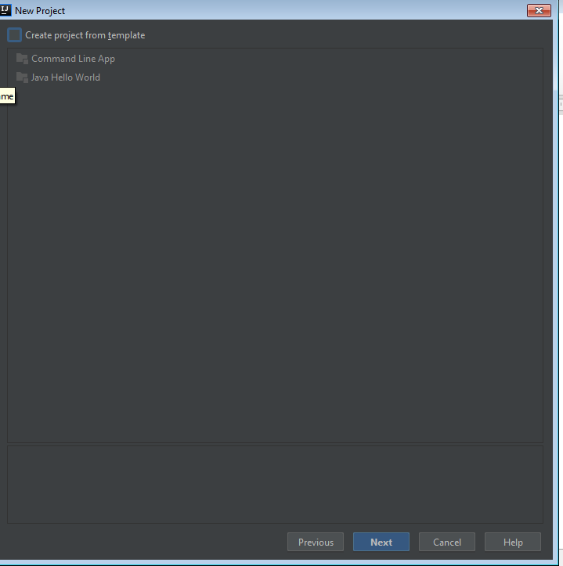

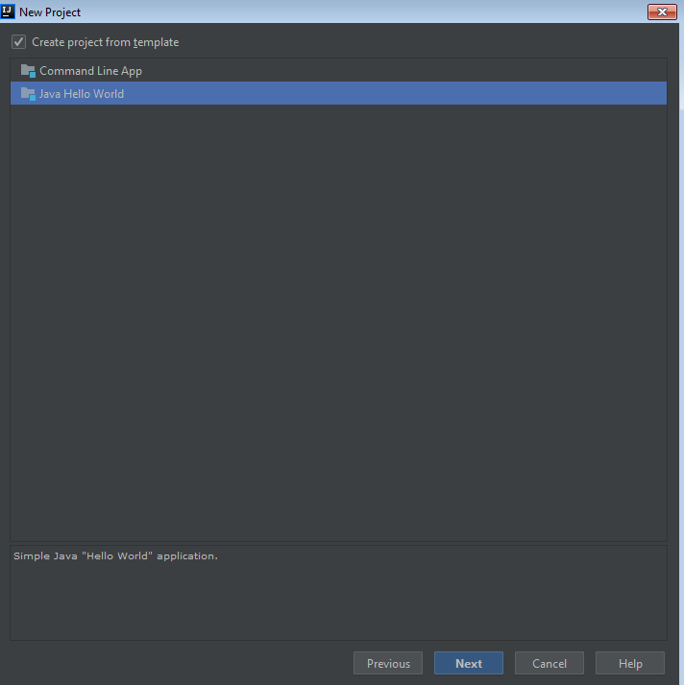
Note: If we are not comfortable with Intellij shortcuts then we can changes the shortcuts from settings.

1) To Open The Class (CTRL+N)
2) Code Completion (CTRL+SPACE)
3) To Find the class, method and varibales (ALT+F7)
4) To see the documentation of class or method (CTRL+Q)
5) To navigate to the declaration of a class, method or variable used somewhere in the code, position the caret at the usage and press (Ctrl+B) / CTRL and click mouse on that
6) You can quickly navigate in the currently edited file with (Ctrl+F12)
7) You can easily rename your classes, methods and variables with automatic correction of all places where they are used. To try it, place the caret at the symbol you want to rename, and press (Shift+F6)
8) You may easily override methods of the base class by pressing (Ctrl+O )
9) The SmartType code completion greatly helps to find methods and variables that are suitable in the current context, by analyzing the expected type of the whole expression. So doing, IntelliJ IDEA pinpoints the top five most suitable results and highlights them on the blue background.
(CTRL+SHIFT+SPACE)

10) To Remove the line (CTRL+Y)

11) To add multiple project in the same workspace go to View(In the menu) >Tool Window > Maven project> Then Click On + Icon and add the project.
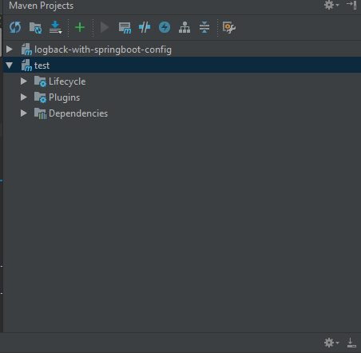

12) To Customize the Kyboard shortcuts need to go to Settings (Ctrl+Alt+S)> Keymap > Main menu > Window > Editor Tabs >

13) To comment the piece of code same as Eclipse (Ctrl+Shift+/) and to uncomment (Ctrl+Shift+\).

14) For Code completion same as Eclipse (Ctrl+Space)

15)
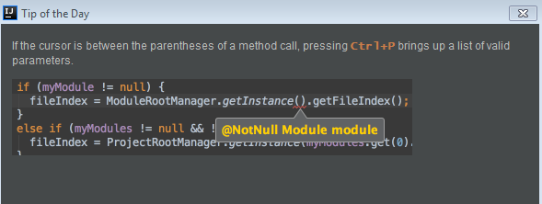

16) Ctrl+Shift+BackSpace brings backs to the place where made some code changes.

17) Ctrl+E brings list of the recently file visited.

18) Alt+Up and Alt+Down keys quickly move between method in the editor.

19) Ctrl+Shift+J shortcut joins two lines into one and removes unnecessary space to match your code.

20) To Change The Theme.It's simple please follow the below step.

- On IntelliJ press 'Ctrl+Alt + S' , this will open 'Setting popup'
- Look For Appearance & Behavior.
- In left panel itself you can see 'Appearance', click on this
- Right side panel you can see Theme: and drop down with following option
  - Dracula
  - IntelliJ
  - Windows
21) To find the word in complete workspace select the particular word and do double shift.

22) Comment and un-comment the code ‘Ctrl+Shift+/’

23) Assigning A New Variable from Method ‘Ctrl+Alt+V’

24) To generate a Code Like Setter/Getter, toString(), Constructor, Override Method. Equals and HashCode. ‘Alt+Insert’

To Configure Git In The Intellij:

1) Install Git From https://git-scm.com/download/win
Follow below url to install GIT
http://toolsqa.com/git/install-git-on-windows/

2) In the Settings/Preferences dialog (Ctrl+Alt+S), select Version Control | Git in the left pane and specify the path to the Git executable.
(Git Executable Path we can get from command prompt by typing “where is git” )
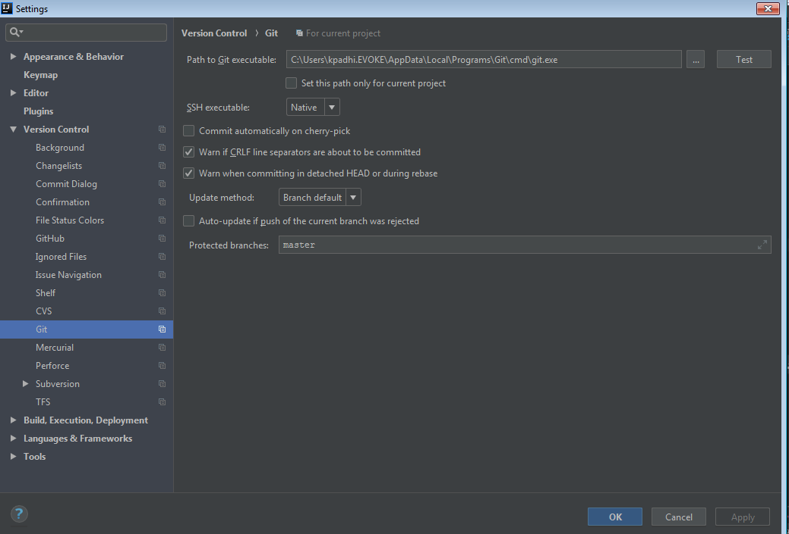

Import Project From Remote(Git):

How to set Environment Variables:

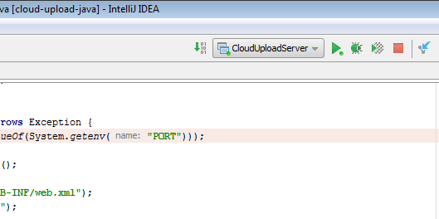
Click on project name dropdown near to start button.

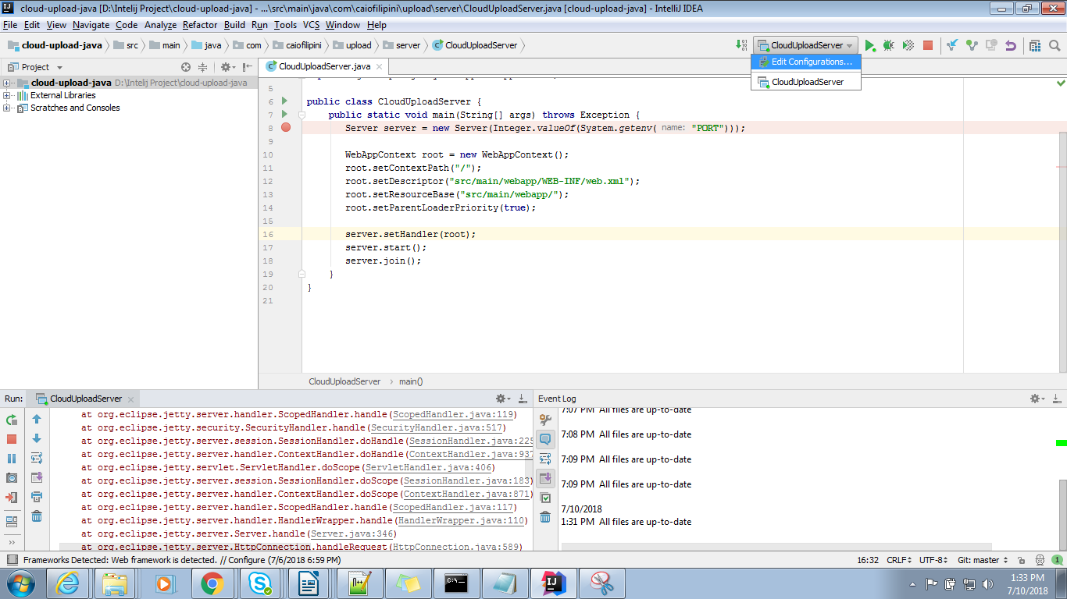
Select Edit Configuration.

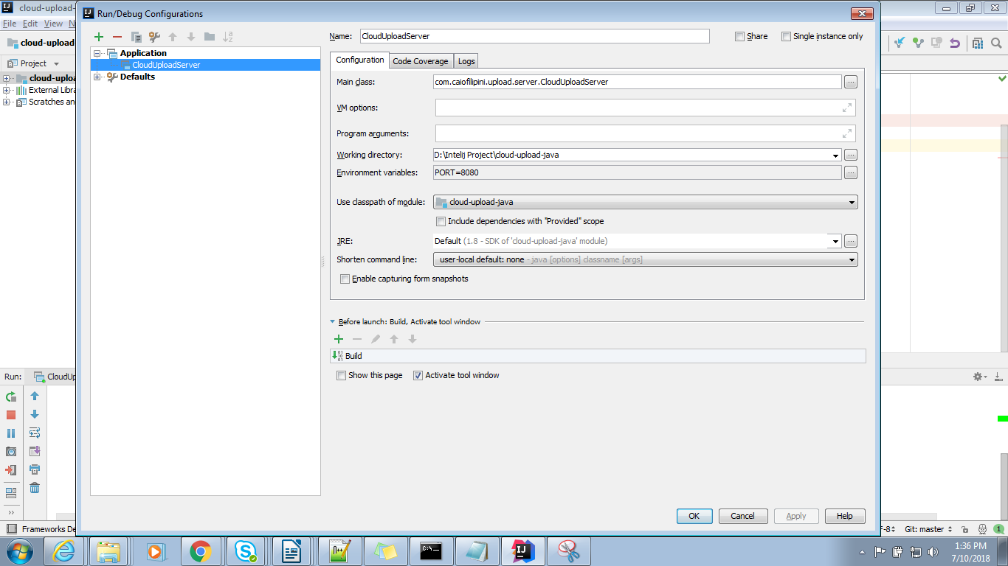

How to start an Application:

If there is a spring boot application we can directly start from main method or we can start the application Plugins section from maven project.
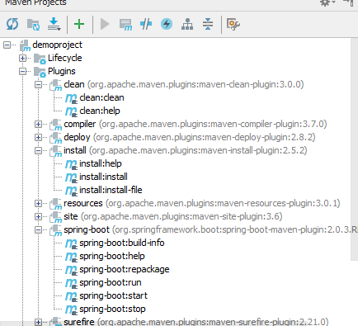

Go to Plugins Section→ Expand Spring-boot module → double click on spring-boot: run

Configure Tomcat Server and deploy the war In Intellij:

There are two way we can configure and deploy the war in tomcat in the project.

A) Configure a maven plugin (LIMITATION: Only we can configure up to Tomcat 7)
Steps 1: Add Tomcat Plugin in the Pom.xml file
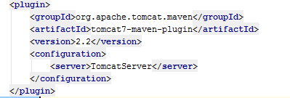

Step 2:
Go to server Edit Configuration Section by selecting from dropdown.
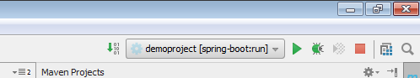

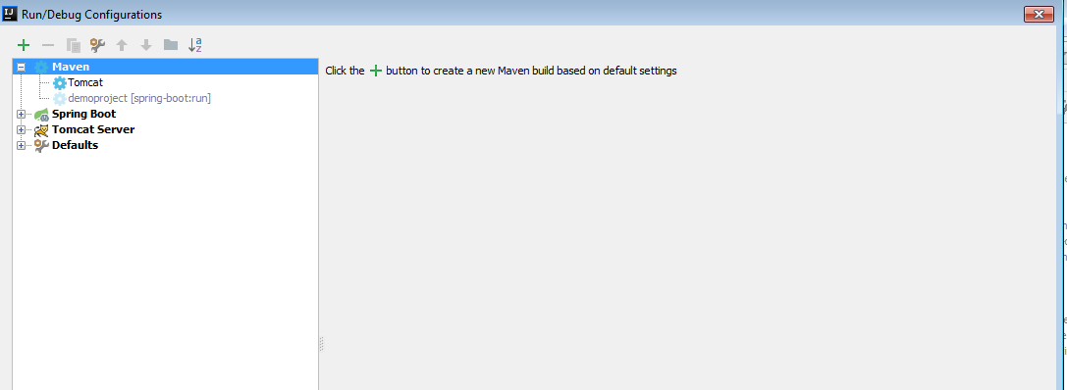

Step 3:
Click Again + icon to add new configuration.

Select Maven From The List.

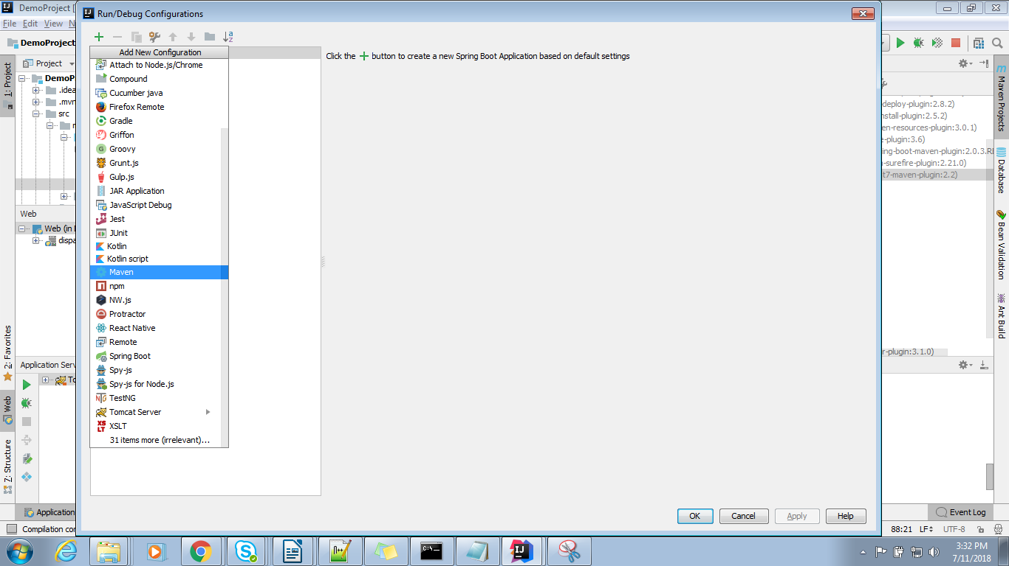
After add the Maven the window will look like below.

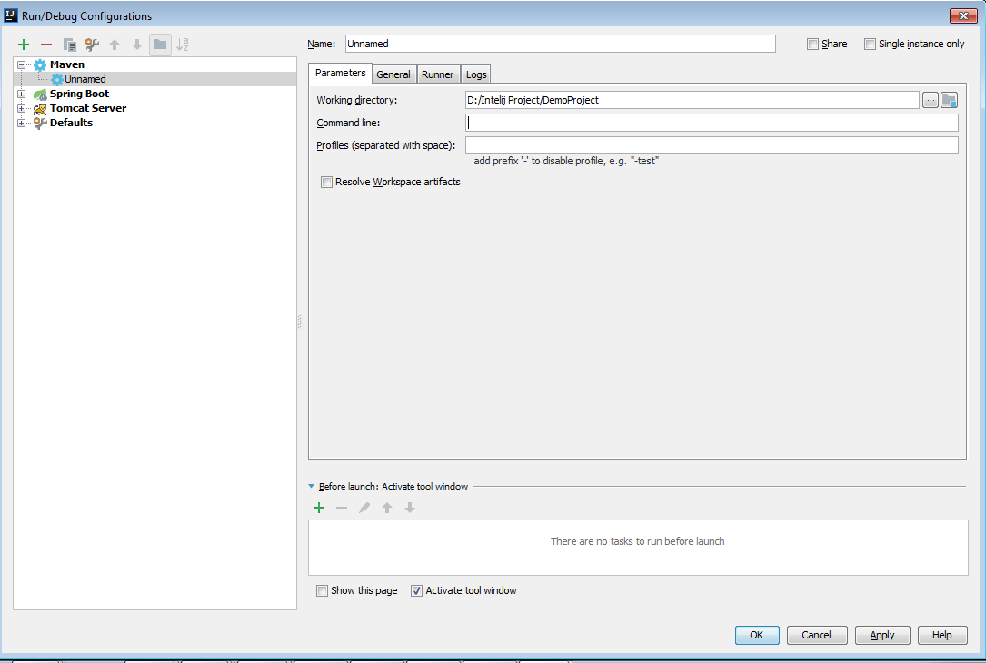
Provide the command in the Command Line Box (tomcat7:run)

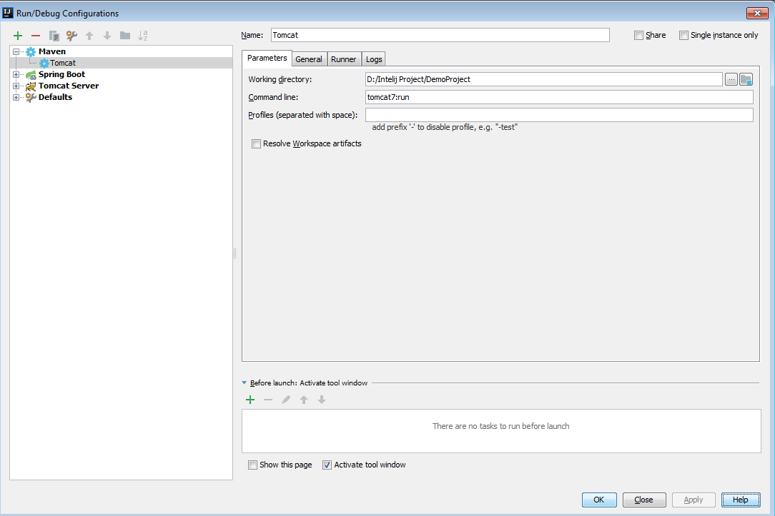
Now we will get Run Configuration section under the project in the maven section.
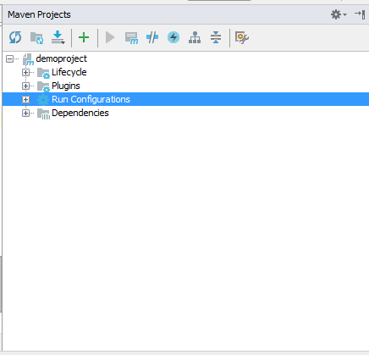

Expand Run Configuration→ Double click on Tomcat
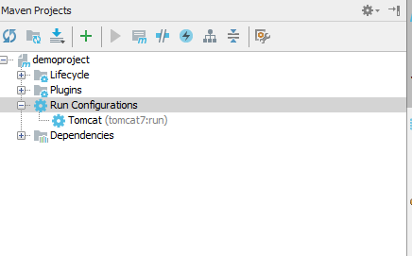

Server will start and run.

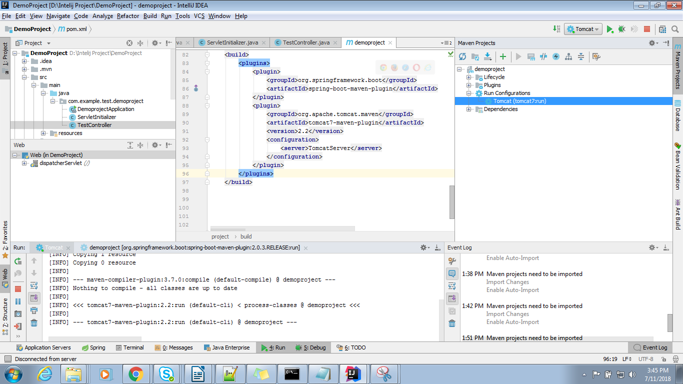
B) Configure an External Server.

Go to Run Configuration → Click the + button and add the artifacts(Project) By Selecting Tomcat Server → Local

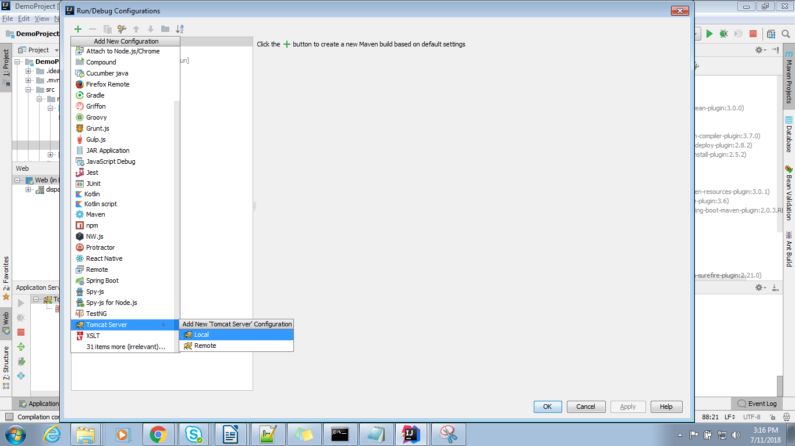
Provide below Information in the screen:

I) Name
II) Configure Application Server By Selecting Tomcat Home Path From Your local
III) if required Change The port number.
IV) Go to Deployment Tab at the top of the window and add the artifacts(Project) by click on + button.
V) Click On Apply And OK.

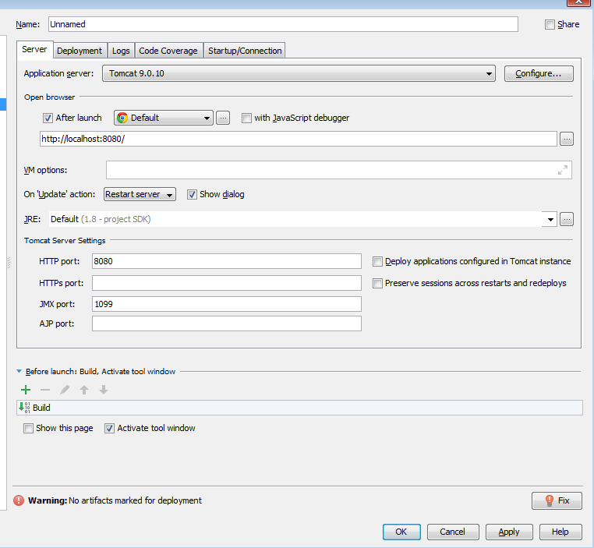

Once we configure the above details click on Application Server Section in the bottom of the IDE.

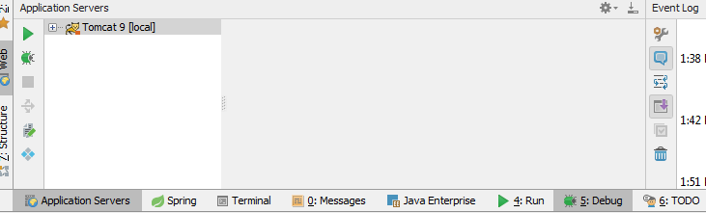
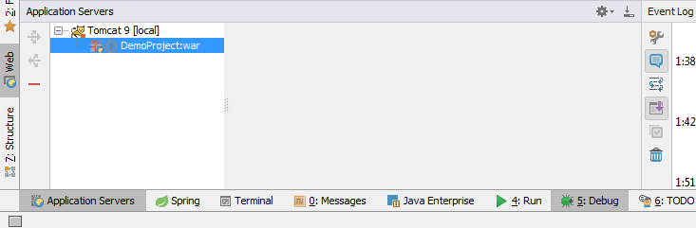
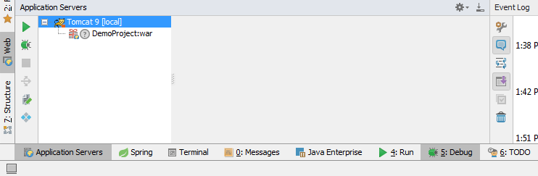
Start the server Either Debug Mode/Normal Mode From side button.

How to configure Sonar Lite:

Go to settings by clicking the Ctrl+Alt+S → Plugins → Search The Sonar Lint Plugin

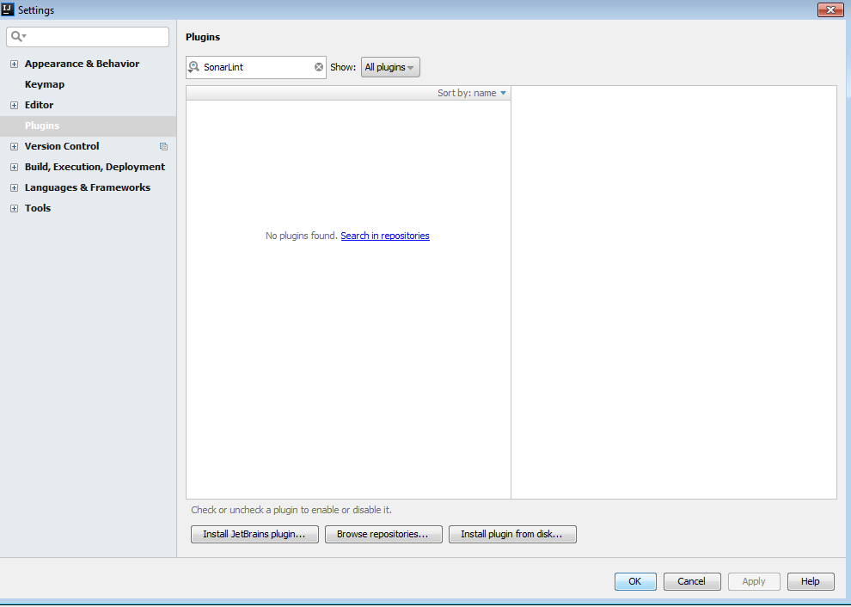
If the Plugin was not installed then we need to search in repositories.
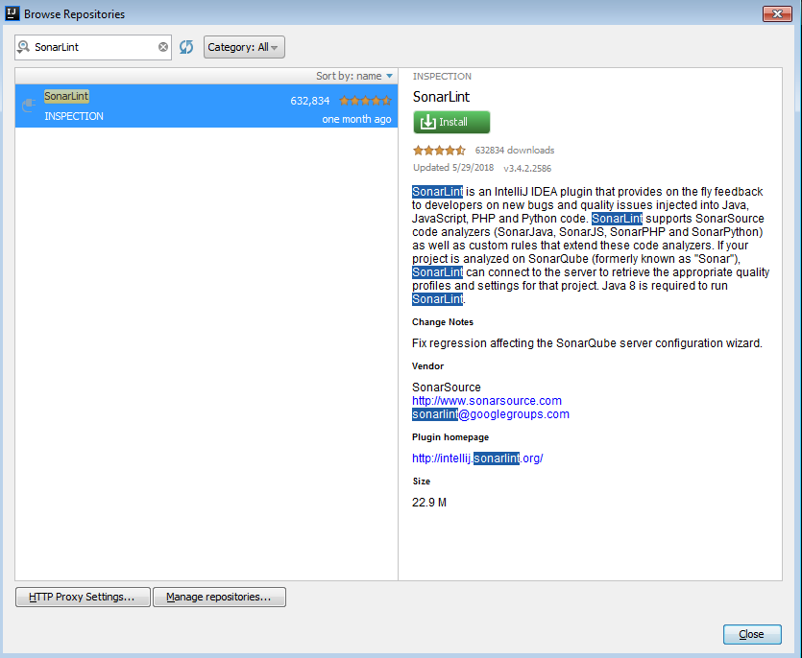
Click on install to install the Pluigin. And do restart The Intellij.
We can find a sonarLint Option on the bottom of the IDEA.

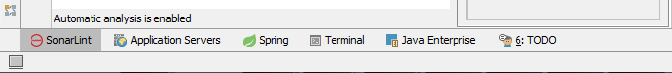
SonarLint will run while writing the code.

–> After writing some of the code SonarLint automatically find our the error which we can reduce.

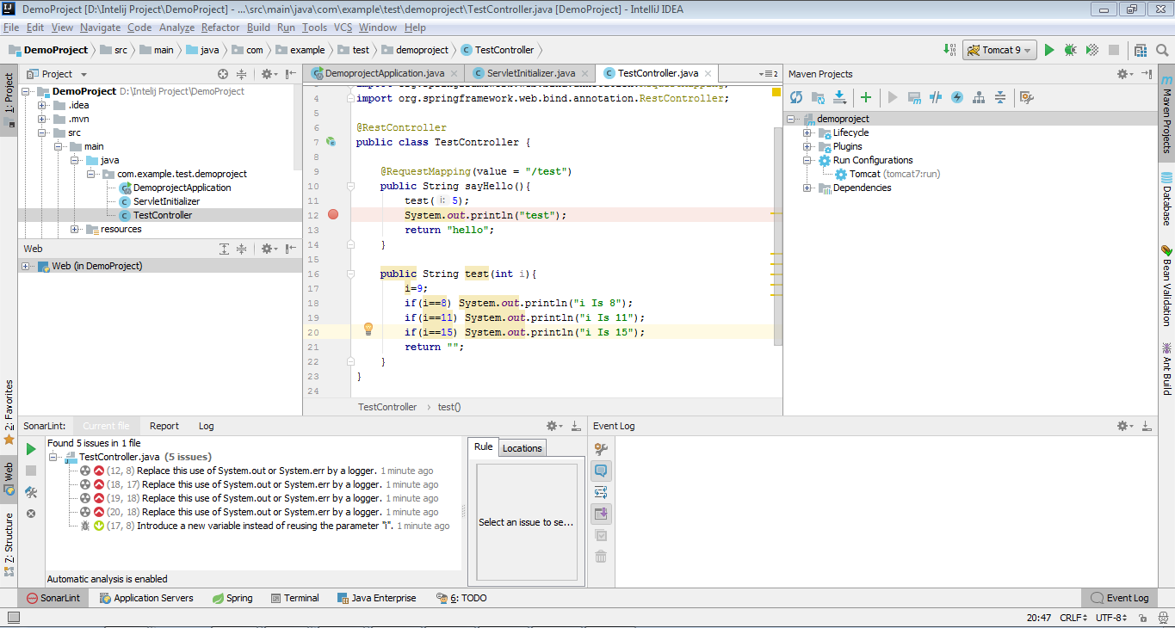

How To Debug The Application:

1) As eclipse We need to start our application in Debug Mode.
2) Click On the space between editor and line number to place a debug point.
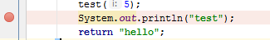

3) Red Color point indicates that debug point.
4) Once the Controll Reach debug point that will stop.
5) To Move Next press F8
6) To terminate Debugger In The Middle F9
7) Go Inside a method while debugging F7
8) We don’t need inspect the code like eclipse as the object value is displaying at the same line like below image.
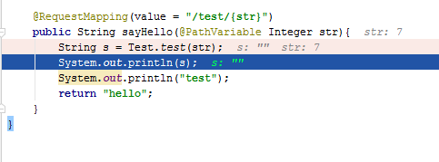

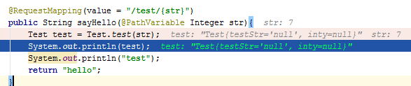

Conclusion:

I eventually came to the conclusion that what IntelliJ calls a "project" is basically what Eclipse calls a "workspace", and what Eclipse calls a "project" is basically what IntelliJ calls a "module".
This can cause confusion to start with, because you tell IntelliJ that you want to add a new "Maven project", which IntelliJ understands to mean you want to add a new "Maven workspace" in Eclipse terminology. So what you really need to tell IntelliJ to do is to create a new module (aka equivalent of an Eclipse project) in the workspace (IntelliJ project).

Because we come from an Eclipse background, most of us just refer to IntelliJ projects as "workspaces" in my organisation, and explicitly qualify "IntelliJ project" if we need to use the word "project". I think this reduces confusion, because an "IntelliJ project" has a different scope from a "Maven project", unlike in Eclipse.

